Welcome!
Date
Name
Spouse
Address
City
State Zip _________
Email

Please Contact By
❑ Card  Phone  Visit

Telephone Best Time to Call
Home ______________
Work ______________

Guest: First Time Second Time
Are you a church member: yes no
Church
City, State

Circle Appropriate Age/Grade Group(s)
Preschool: Ages: B-1 2-3 4-5

Children: Grades: K 1 2 3 4 5 6
Youth: Grades: 7 8 9 10 11 12
Adults: Ages:18-29 30s 40s 50s 60s+

How did you learn about our church?
Newspaper Friend Yellow Pages Mail
Other

I am a guest of:

New in the Community? Yes No
Names & ages of children at home

Weekly Service & Activity Schedule

April 19, 2015
9:45 a.m. Sunday School
11:00 a.m. Morning Worship Service
12 noon Covered Dish Lunch for David & Cissy
6:00 p.m. Evening Worship

Week of April 19, 2015

Wednesday 7:00 p.m. Adult Prayer & Bible Study
Thursday 10:00 a.m. Adult Fellowship

Upcoming Events
April
26…………..….…………….…………….. The Lord’s Supper
May
3…………..…………………………..…………..Kids In Action
10…………………………….….Texas Baptist World Hunger
14………………………………….…………..Adult Fellowship
Covered Dish Lunch today in the Fellowship Hall to welcome David & Cissy


We will be observing the Lord’s Supper next Sunday April 26

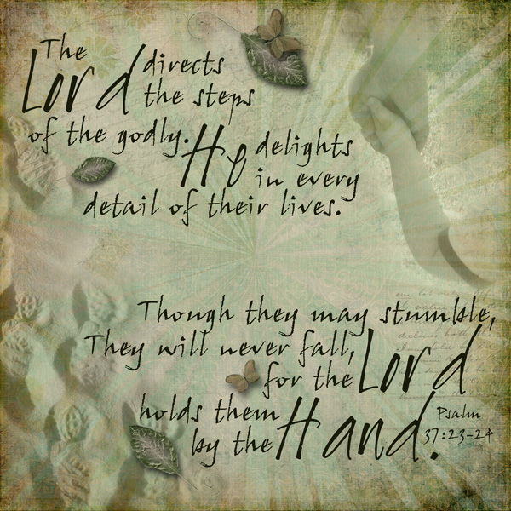

Knobbs Springs Baptist Church

April 19, 2015

Church Information:

KnobbsSpringsBC.com KnobbsSpringsBaptist@gmail.com
1662 CR 305, McDade, Texas 78650 512-273-2743
David Atwood, Pastor Cell 512-470-5098
Home 512-856-2819
Patti Radford, Office Manager 512-968-7821

